

|  |
| --- |
| **User Guide for ALM Helpdesk (Service Request)** |

Table of Contents

1. Objective 3

2. Procedure 3

3. Scope and Support 4

3.1 Scope 4

3.2 Support 4

# Objective

This documents provides a step by step procedure for raising ALM Helpdesk requests (Service Request only) for implementation / migration of projects using Atlassian and Open Source tool stacks to Centralized Server.

# Procedure

1. Login to Cybage Helpdesk from MIS and click on ALM.

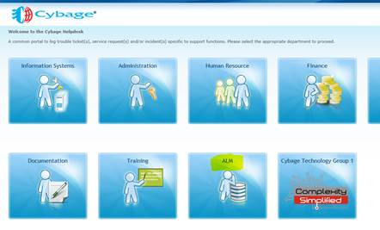

1. On the following window, click on New Tickets under User:

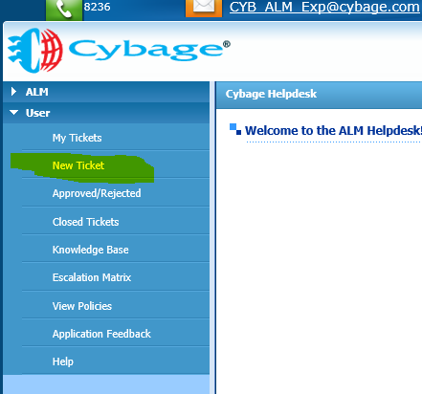

1. On the following window, please enter the required details, select project and select the relevant Category:

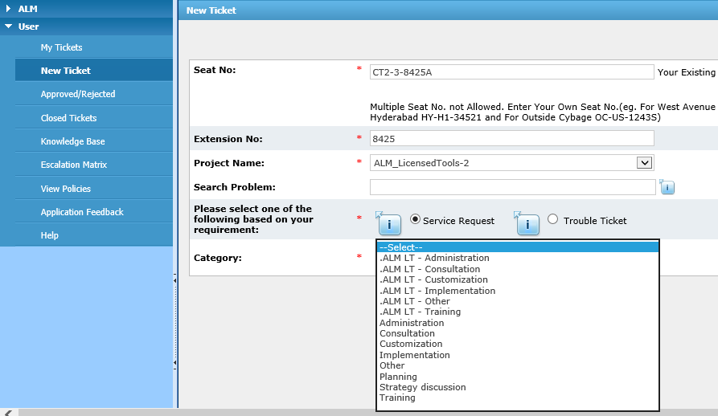

1. Select below highlighted category and problem for adding user to central server:

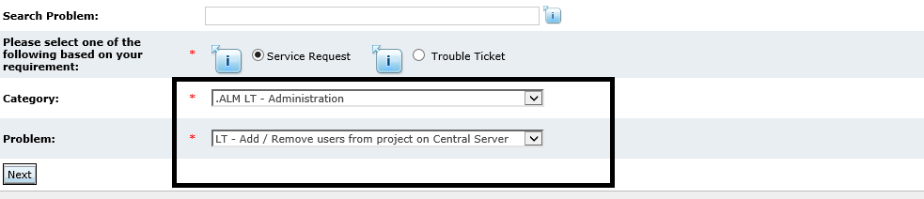

# Scope and Support

## Scope

Appropriate Category named **“.ALM – LT”** should be selected as per the requirements only for:

* Any project that is not using Microsoft TFS as the tool stack for ALM related activities.
* Any project that has started and interest has been shown to use Non Microsoft TFS tool stack for ALM related activities.

## Support

For any support or quries please contact:

* **Helpdesk Support:**

If facing technical challenges while accessing Helpdesk or access to the same.

* **ALM Team:**

For clarifications related to any categories / problems / questions asked while raising the request.